**FA1 Hands-on QP**

**Time: 3 Hrs Mark: 50**

**Instruction to Candidates:**

* It is a controlled book test. Please follow the guidelines provided by Invigilator
* The code will be evaluated only after submitting it to the submission folder (server).
* **If the timestamp of the file is greater than the submission time the test will not be evaluated.**
* **You are not supposed to use any network resources**

**Instructions to use the project file provided**

* Download the project **Bayview Club – ToTrainee** in to your system and unzip it
* Open a new workspace in Visual Studio Code
* Open only the **Bayview Club – ToTrainee** folder in your Visual Studio Code workspace
* Do not change the partial code given to you.
* Do not change the IDs.
* Make sure your output is exactly the same as the screenshots.
* Always run the live server in chrome browser.
* Use Bootstrap classes wherever possible

**Submission guideline**: Submit the project by copying it into a folder with the folder name as your **<Empno>**

**Problem description**

Bayview Club allows the users to register for lessons in sports.

The files present in the given project are described as below:

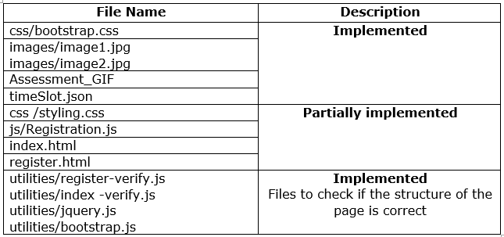

**index.html**

The design of **index.html** should be as shown below:

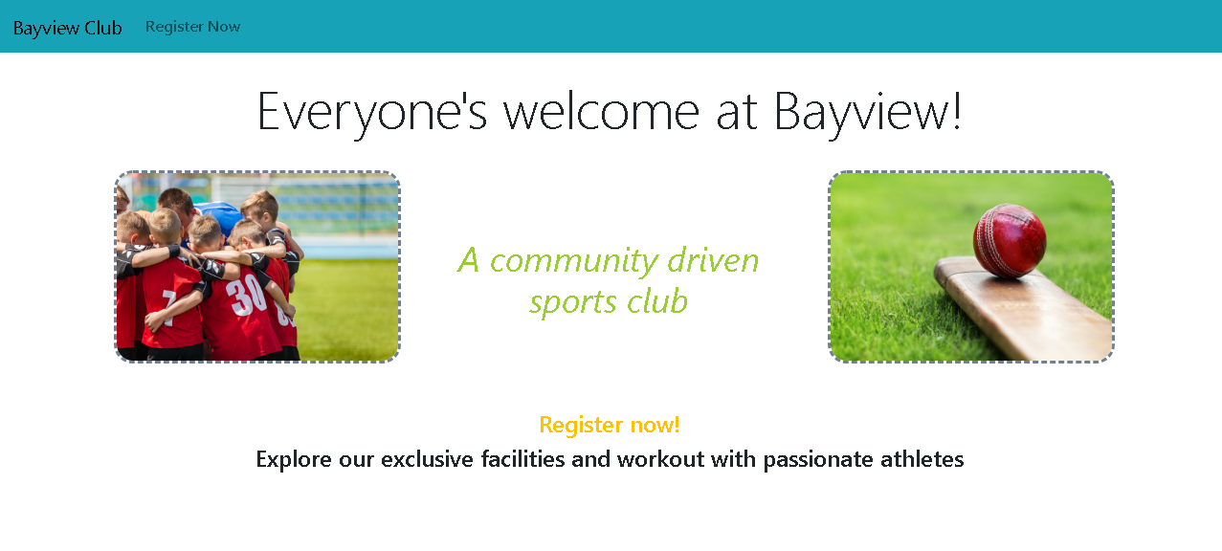

* Heading “Everyone's welcome at Bayview!” must be inside **h1 tag.** It should be styled using “display-4” bootstrap property and center aligned.
* Use **1 row – 3 column** grid system to split the content of paragraph and images.

Style the images and paragraph as follows:

* + **Image 1:** column grid of 3 with offset value 1 (medium screen). It should have a dashed slategrey border of 3px and border radius of 20px. Its width is 300px. Should have **id as image1**
  + **Paragraph:** column grid of 4 (medium screen). It should be in italics, have *normal* font weight, font size of 36px and yellowgreen in color with 90px padding at the top. Should have **id as paragraph**
  + **Image 2:** column grid of 3(medium screen) and same styling as

Image 1. Should have **id as image2**

* “Register now!” and “Explore our exclusive…” should be in h4 and h5 tags respectively and should be center aligned.

“Register now!” should be of warning bootstrap class.

* When **Register now** link present in navigation bar is clicked, it should navigate to **register.html** page.

**Note**: Implement the “**paragraph”** and “**image1, image2”** id selectors provided in styling.css to achieve the paragraph and image styling.

**register.html**

* When **Register now** link is clicked from **index.html**, then initially **register.html** view should be displayed as shown below:

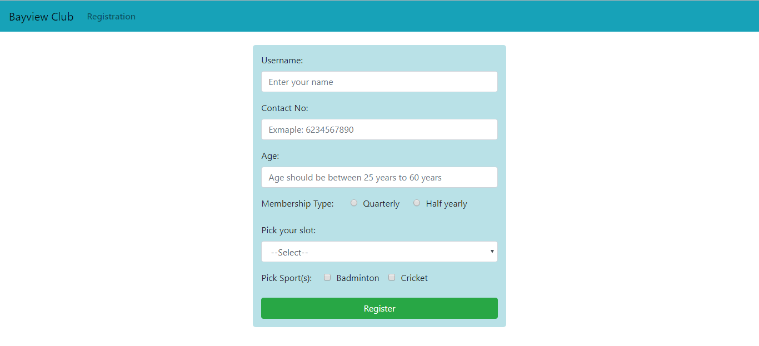

* Use the **“formborder”** class to style the form.
* The form should be placed in a column grid system of 4 columns and 4 offset.
* The navbar features are as shown in the above screenshot.

**Note: Ensure that you use the ID’s mentioned below. Else you will lose marks.**

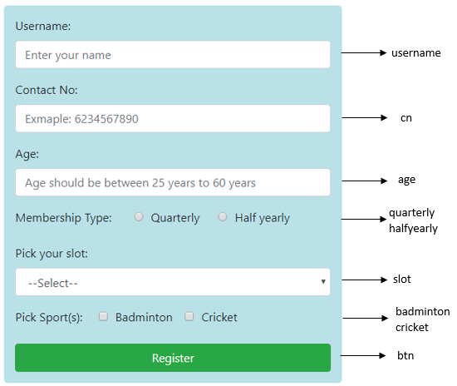

**Note: Refer GIF**

**Note: A utility file is already linked with this page. If you open the console, it will tell you if any ID’s are missing**

* All the labels must have “for” attribute.
* If **Bayview Club** is clicked, it should navigate back to **index.html.**
* **Pick your slot** dropdown should be populated statically using the table given below:

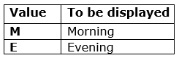

* **Membership Type** radio buttons should be populated statically using the table given below:

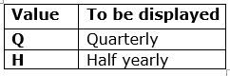

* **Pick sport(s)** checkbox should be populated statically using the table given below:

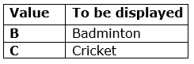

**Note:** The values are NOT case sensitive. You can use any case

* Perform the **HTML** **validations** mentioned below:
* All fields except checkboxes are **required fields**

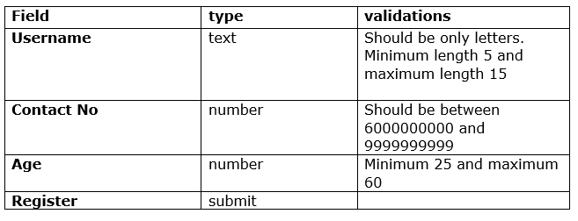

**Registration.js**

**getTime():** This function must be invoked onchange of **Pick your slot** field

* + This function should get the slot chosen by the user.
  + It must send a AJAX request to fetch the object from the *timeSlot.json* file provided.
  + For a slot chosen by user, display the corresponding message.

in a span tag with id: “**timeMessage**”

**checkAge():** This function must be invokedonkeyupof the **Age** field

* + Get the age entered by the user.
  + If age is less than 18 display message “**Member has to be above 25 years old to register with us**”.
  + If age is greater than 60 display message “**Member should not be more than 60 years old”**
  + The error message must be displayed in a span tag with id: “**ageError**”

**calculateFees():** This function must be invoked onsubmit of the Form

Calculate the **total cost for registration** based on the following price(in Rs.) for each:

* + **Base price: 5000**

**Additional cost: If-**

* + - Quarterly: 2500
    - Half yearly: 5000
    - Morning: 1000
    - Evening: 1500
    - Cricket: 2000
    - Badminton: 1000
* Display the total cost in the span tag with the id as “**successMessage**” and the message is:

“**Registered. The final cost is Rs. <total_cost>.**”

**Sample Input and Output:**

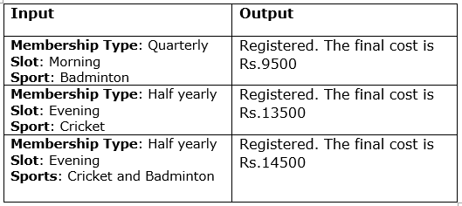

* Use appropriate bootstrap classes for messages displayed.

**~~~~~~~~~~~~~~~~All the Best~~~~~~~~~~~~~~~~**